**2. Integration Strategy**

**2.1. Entry Criteria**

This section describes the prerequisites that need to be met before integration testing can be started.

First of all, code inspection has to be performed on all the code in order to find possible issues and to ensure maintainability and respect of conventions.   
Taking as reference the component diagram (2.2 from DD), the following component must be unit-tested before our integration tests:

• Notifications displayer (Supervisor)  
• Sensor/actuator manager (Car)  
• Info displayer (Car)  
• Mobile App (User)  
• DB  
• Email gateway  
• Push gateway

The DB component represents the database: because the database run on the same system of the application server, in the component diagram it is represented as a simple component; following this convention, we will continue to represent it as a component and to consider it as part of the “central server” subsystem.

In addition, there are present in the diagram 2 components which represent external services (Google maps and bank service), which can be considered already reliable and do not need to be unit tested.

We should test all non-trivial methods, getter and setter methods can be skipped.

The components “User” and “Safe park slot”, which contain only getter and setter methods, are considered as already tested.

**2.2. Elements to be integrated**

The elements to be integrated are all the elements represented in the already mentioned component diagram, considering that our system must cooperate with 2 external services (google maps and the bank service).

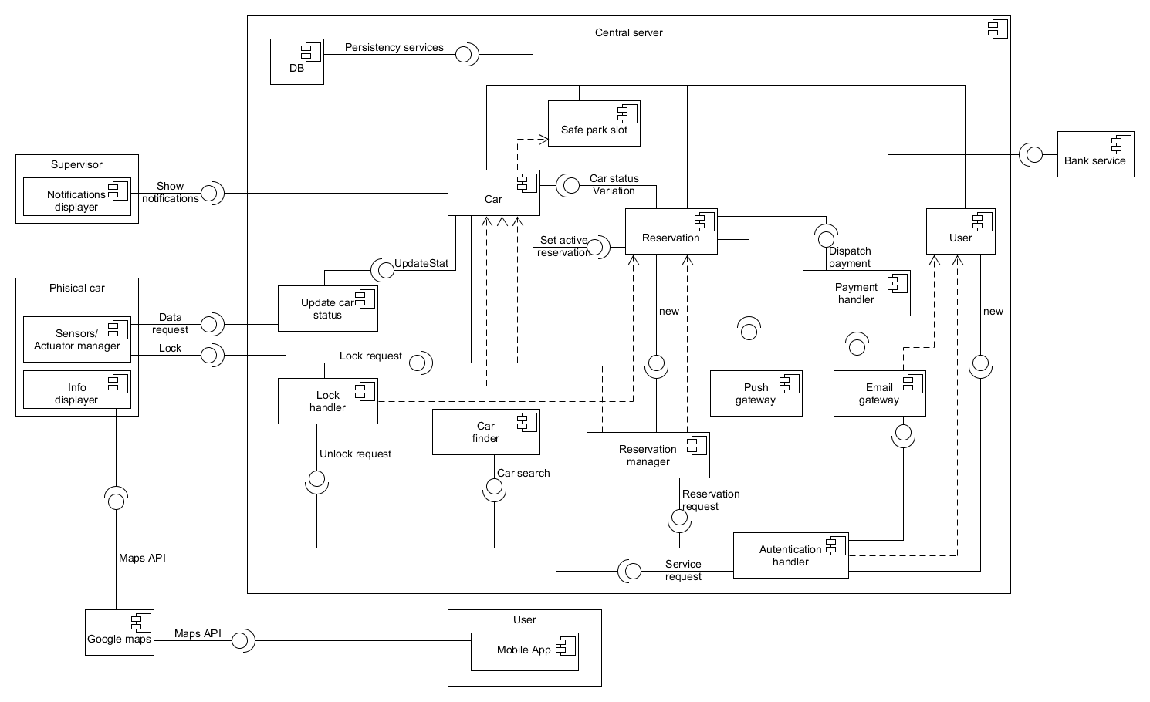

*Component diagram*

**2.3. Integration testing strategy**

The integration strategy that we decided to follow is the bottom-up approach. The main reason for this choice is that we assume that we already have the unit-test for some of the simplest components, so we can proceed from the bottom.

Moreover, except for the central server, the other high-level components are composed by simple parts that we consider as atomic; the high level components communicate through well defined interfaces (REST API), so the integration of each of them will not be hard in a later time.

In addition, this approach has other intrinsic advantages: we can limit the usage of stubs, the errors are well located and, if the realization of the components follows a bottom-up approach too, the testing of lower level modules can take place earlier.

**2.4. Sequence of component/function integration**

**2.4.1. Software integration sequence**

In this section it will be shown the sequence of the components’ integration.

As mentioned above, we consider the high-level components “User”, “Supervisor” and “Physical car” as atomic subsystems, and therefore they are not consider in this section; in the following figure we describe in detail the integration sequence of the components of the “Central server” subsystem.

The bottom-up approach has been respected in the majority of the cases, with only two exception: it’s present a circular dependency between the “Car” and “Reservation” components, that forces us to take a choice on which one we implement first, and the push gateway, which have to send information both to the physical car and to the mobile app: we will need a stub for the latter one.

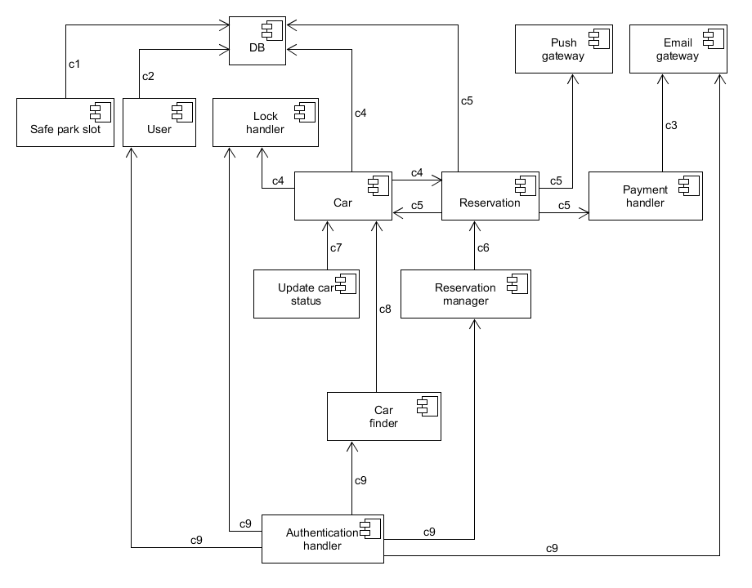

*Central server integration sequence*

|  |  |  |
| --- | --- | --- |
| N° | Component | Integrates with |
| c1 | Safe park slot | DB |
| c2 | User | DB |
| c3 | Payment handler | Email gateway |
| c4 | Car | DB, Reservation, Lock handler |
| c5 | Reservation | DB, Car, Push gateway, Payment handler |
| c6 | Reservation manager | Reservation |
| c7 | Update car status | Car |
| c8 | Car finder | Car |
| C9 | Authentication handler | User, Lock handler, Car finder,  Reservation manager, Email gateway |

**2.4.2. Subsystem integration sequence**

For subsystem integration we follow the bottom-up approach too. The reason to do so is that it’s simpler to implement driver for testing the low level components, instead of making coherent stubs of the subsystems. Moreover, a working central server is needed to test in a profitable way the mobile app (User subsystem).

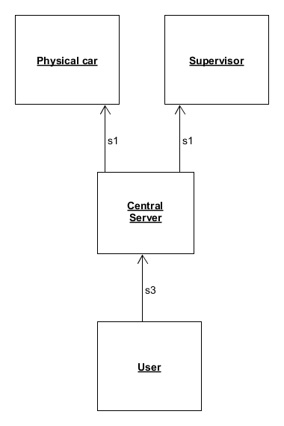

*Subsystems integration sequence*

|  |  |  |
| --- | --- | --- |
| N° | Subsystem | Integrates with |
| s1 | Central server | Physical car, Supervisor |
| s2 | User | Central server |

**3. Individual steps and test description**

**3.1 Integration test case c1**

|  |  |
| --- | --- |
| Test Case Identifier | C1T1 |
| Test Item(s) | Safe park slot -> DB |
| Input Specification | Typical queries on table Safe park slot |
| Output Specification | Correct result returned |
| Environmental Needs | DB |

**3.2 Integration test case c2**

|  |  |
| --- | --- |
| Test Case Identifier | C2T1 |
| Test Item(s) | User -> DB |
| Input Specification | Typical queries on table Safe park slot |
| Output Specification | Correct result returned / correct data insertion |
| Environmental Needs | DB |

**3.3 Integration test case c3**

|  |  |
| --- | --- |
| Test Case Identifier | C3T1 |
| Test Item(s) | Payment handler -> Email gateway |
| Input Specification | Typical payment handler input |
| Output Specification | Correct request for bank services / Correct email generation |
| Environmental Needs | Email gateway |

**3.4 Integration test case c4**

|  |  |
| --- | --- |
| Test Case Identifier | C4T1 |
| Test Item(s) | Car -> DB |
| Input Specification | Typical queries on table Car |
| Output Specification | Correct result returned / correct data insertion |
| Environmental Needs | DB |

|  |  |
| --- | --- |
| Test Case Identifier | C4T2 |
| Test Item(s) | Car -> Reservation |
| Input Specification | Typical input for “car status variation” method of reservation |
| Output Specification | Check if the correct method of reservation is called |
| Environmental Needs | Update car status driver, C1, Reservation stub |

|  |  |
| --- | --- |
| Test Case Identifier | C4T3 |
| Test Item(s) | Car -> Lock handler |
| Input Specification | Typical input for “Lock handler” |
| Output Specification | Check if the request is sent under the correct conditions, check if the physical car correctly locks |
| Environmental Needs | Physical car, Update car status driver, Reservation driver |

**3.5 Integration test case c5**

|  |  |
| --- | --- |
| Test Case Identifier | C5T1 |
| Test Item(s) | Reservation -> DB |
| Input Specification | Typical queries on table Reservation |
| Output Specification | Correct data insertion |
| Environmental Needs | DB |

|  |  |
| --- | --- |
| Test Case Identifier | C5T2 |
| Test Item(s) | Reservation -> Car |
| Input Specification | Typical input for “Set active reservation” method of reservation |
| Output Specification | Check if the correct method of car is called |
| Environmental Needs | Reservation manager driver, C4 |

|  |  |
| --- | --- |
| Test Case Identifier | C5T3 |
| Test Item(s) | Reservation -> Push gateway |
| Input Specification | Typical “push gateway” input |
| Output Specification | Check if the correct data are dispatched |
| Environmental Needs | Mobile app (from user subsystem) stub, Physical car |

|  |  |
| --- | --- |
| Test Case Identifier | C5T4 |
| Test Item(s) | Reservation -> Payment handler |
| Input Specification | Typical “Payment handler” input |
| Output Specification | Check if the correct method of car is called |
| Environmental Needs | C3 |

**3.6 Integration test case c6**

|  |  |
| --- | --- |
| Test Case Identifier | C6T1 |
| Test Item(s) | Reservation Manager -> Reservation |
| Input Specification | Typical “Reservation manager” input |
| Output Specification | Check if a new reservation is correctly created, observing the requirements criteria |
| Environmental Needs | C4, C5 |

**3.7 Integration test case c7**

|  |  |
| --- | --- |
| Test Case Identifier | C7T1 |
| Test Item(s) | Update car status -> Car |
| Input Specification | Typical “Update car status” input |
| Output Specification | Check if the car’s data are correctly updated |
| Environmental Needs | C4, Physical car |

**3.8 Integration test case c8**

|  |  |
| --- | --- |
| Test Case Identifier | C8T1 |
| Test Item(s) | Car finder -> Car |
| Input Specification | Typical “Car finder” input |
| Output Specification | Check if the position of the car which respects the search criteria are returned |
| Environmental Needs | C4 |

**3.9 Integration test case c9**

|  |  |
| --- | --- |
| Test Case Identifier | C9T1 |
| Test Item(s) | Authentication handler -> User, Email gatewat |
| Input Specification | Typical “Authentication handler” input for the creation of a new user |
| Output Specification | Correct creation of a new user, email containing the password correctly sent |
| Environmental Needs | C2, Email gateway |

|  |  |
| --- | --- |
| Test Case Identifier | C9T2 |
| Test Item(s) | Authentication handler -> Lock handler |
| Input Specification | Typical “Authentication handler” input for an unlock request |
| Output Specification | Check if the physical car correctly unlocks under the right conditions |
| Environmental Needs | C4, C2 |

|  |  |
| --- | --- |
| Test Case Identifier | C9T3 |
| Test Item(s) | Authentication handler -> Car finder |
| Input Specification | Typical “Authentication handler” input for the research of a car |
| Output Specification | Check if the “car finder” method is correctly called |
| Environmental Needs | C4, C2 |

|  |  |
| --- | --- |
| Test Case Identifier | C9T4 |
| Test Item(s) | Authentication handler -> Reservation manager |
| Input Specification | Typical “Authentication handler” input for the creation of a new reservation |
| Output Specification | Check if the “Reservation manager” method is correctly called |
| Environmental Needs | C6, C2 |

**5. Program stubs and test data required**

**5.1. Stubs**

Since we decided to follow a bottom-up approach, we only have 2 stubs to be developed during the test phase:

**5.1.1. Reservation Stub**

Usage: C4T2

Description: This stub is required to test the correctness of the interaction between the “Car” and the “Reservation” components.

In particular, when Car calls the “Car status variation” method, under certain conditions the reservation of the car can change status from active to expired: this cause the call of the “Set active reservation” method of car by the reservation.

**5.1.2. Mobile app stub**

Usage: C5T3

Description: This stub is required to test the correctness of the information sent through the push gateway; it is not necessary to emulate the entire mobile app, but the only functionality needed is the receipt of the pushed notifications.

**5.2. Data for tests**

We will initially populate the database with fake data regarding Cars and Safe area (including safe park slots); these are the only information strictly needed by some components before starting the test. Other information (such as users, reservations) could be inserted during the various test phases.

**6. Effort spent**

Gabriele:

27/12/16: 2h

28/12/16: 2h

29/12/16: 6h

30/12/16: 3h